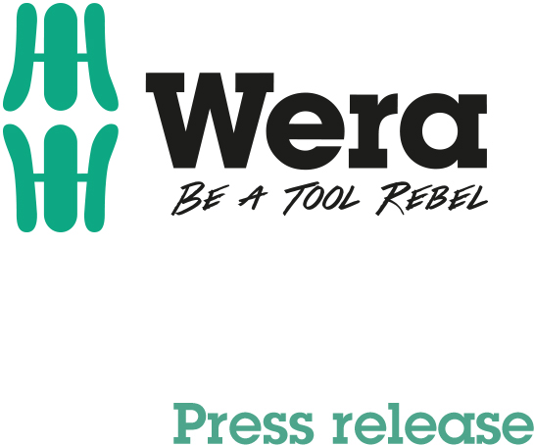

Date: 29/11/2017
Editor: Detlef Seyfarth

Searched and found:
Wera chooses the video of the year

Wuppertal. Assembly tool maker Wera called on all tool rebels and sympathizers to unleash their creativity and produce unusual videos about the Wera brand – in accordance with the motto "Be a Tool Rebel".

What we wanted were unusual, surprising and attention-grabbing clips that further spread the Tool Rebel fever sparked by Wera. In terms of creativity, there were no limits. The guiding principle was that life can be simpler, better and more beautiful if you never give up and question the tried and tested time and time again.

There were quite a few strong results. As an example, a production is presented here, reminiscent of a smash-hit movie. Thanks to Wera, you do not necessarily have to use the most obvious tool to free yourself from a predicament.
See for yourself, view the video with this link or simply scan the QR code in the image:
https://www.spotrocker.de/spots/wera/be-a-tool-rebel/be-a-tool-rebel---free-yourself

Wera will gradually publish the five award-winning videos on the Internet and then present them at the Cologne Hardware Fair 2018.

If you want to know more about the Tool Rebels:

https://www.facebook.com/weratoolrebels/

Further Information:
Wera Werkzeuge GmbH
Korzerter Straße 21-25, 42349 Wuppertal/Germany
Phone: +49 202 4045311, Fax: +49 202 403634
E-mail: info@wera.de, Internet: www.wera.de

TECHNO PRESS

Running count 1,256 characters

Caption:

01-Wera-Screenshot
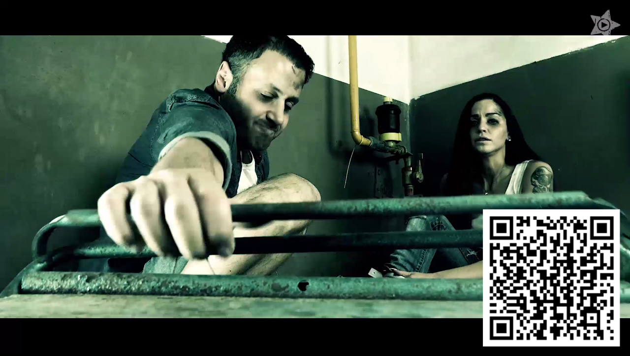
A couple is in an awkward position. Will the battered toolbox the man is reaching for bring salvation? For the answer, simply scan the QR code, which takes you directly to the video.

Screenshot: Spotrocker.de

